Experiment-10
Question: 1
Write a program to display a/b where a and b are integers. If b=0, display infinite by handling the zero division error.
Code:
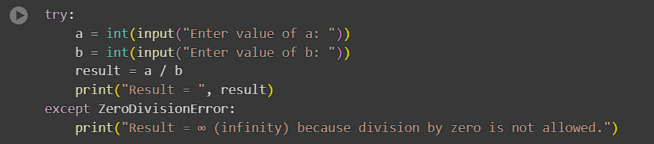
Output:

Question: 2
Write a program in python to demonstrate different types of exceptions and errors.
Code:
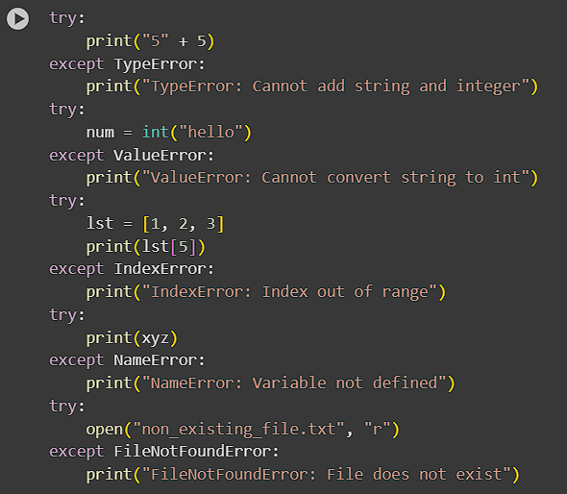
Output:
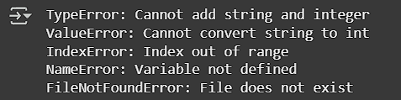

Question: 3
Write a program in python to demonstrate try, Except with finally block. What is the need of finally block in python explain this.
Code:
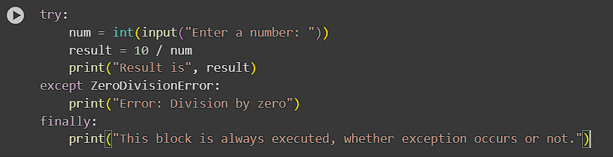
Output:
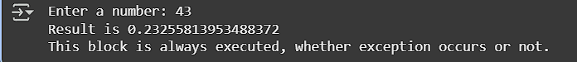

Submitted by:
Name= Abhinav Sharma
Reg no.= 2401020441
Branch= AI & DS
Group= 4

